Lab 3
sahil Saini Salaria
Reg: 180905048
Roll No 11C

Q1

def calculator(a,b,op):
switcher={
'*':a*b,
'//':a/b,
'+':a+b,
'-':a-b,
}
return switcher[op]

a=input("Enter first number:")
b=input("Enter second number:")
op=raw_input("Enter Operation to do (hint: + - * ): ")
res=calculator(a,b,op)
print(res)

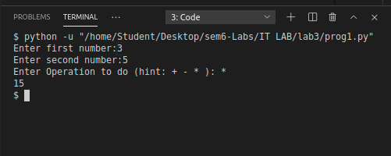

Q2

f=open('prog1.py','r')
f2=open('newfile.txt','w+')
lines=f.readlines()
for line in reversed(lines):
line=line[::-1]
f2.write(line)

f2.close()

f2=open('newfile.txt','r')
for line in f2:
print(line)

f.close()
f2.close()

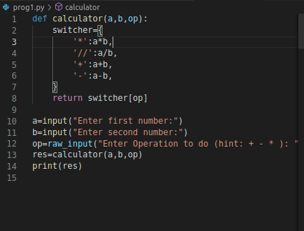

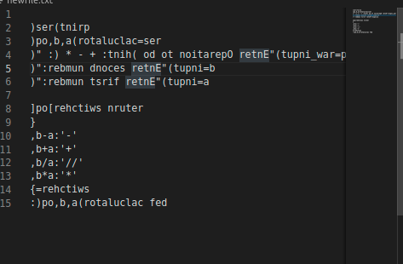

Q3

def binarySearch(arr,left,right,x):
if left>=right:
return -1
mid=(left+right)/2
if arr[mid]==x:
return mid
elif x>arr[mid]:
return binarySearch(arr,mid,right,x)
else:
return binarySearch(arr,left,mid,x)

arr=[]
n=int(input("Enter the value of n:"))
print("Enter array values;")
for i in range(0,n):
arr.append(int(input()))

print("\n")
x=int(input("Enter number to serach:"))
res=binarySearch(arr,0,len(arr),x)
print(res)

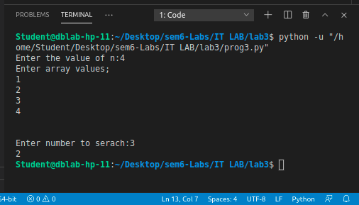

Q4

def sort_it(myStr):
words = [word.lower() for word in myStr.split()]
words.sort()
str_ret=""
for word in words:
str_ret=str_ret+" " +word

return str_ret

f=open('file1.txt','r')

str_arr=""
for line in f:
str_arr=str_arr+sort_it(line)

str_arr=sort_it(str_arr)
print(str_arr)

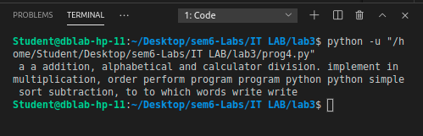

Additional 1

def linearSearch(arr,x):
for i in range(0,len(arr)):
if x==arr[i]:
return i

arr=[]
n=int(input("Enter the value of n:"))
print("Enter array values:")
for i in range(0,n):
arr.append(int(input()))

print("\n")
x=int(input("Enter number to serach:"))
res=linearSearch(arr,x)
if res == None:
print("Noty found!")

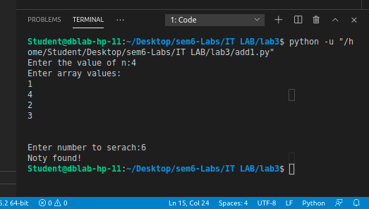

Additional2

def BubbleSort(arr):
n=len(arr)
for i in range(0,n-1):
for j in range(0,n-i-1):
if(arr[j]>arr[j+1]):
temp=arr[j]
arr[j]=arr[j+1]
arr[j+1]=temp

return arr

arr=[]
n=int(input("Enter the value of n:"))
print("Enter array values:")
for i in range(0,n):
arr.append(int(input()))

print("\n")

print("Array before Sorting:")
print(arr)
arr=BubbleSort(arr)
print("Sortred Array:")
print(arr)

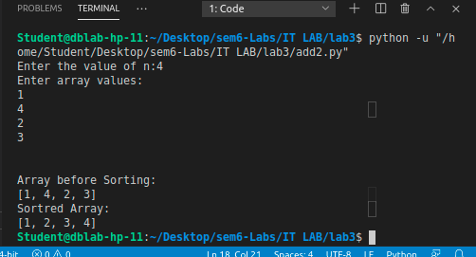

Additional 3

X = [[12,7,3],
[4 ,5,6],
[7 ,8,9]]

Y = [[5,8,1,2],
[6,7,3,0],
[4,5,9,1]]

result = [[0,0,0,0],
[0,0,0,0],
[0,0,0,0]]

for i in range(len(X)):
for j in range(len(Y[0])):
for k in range(len(Y)):
result[i][j] += X[i][k] * Y[k][j]

for r in result:
print(r)

